# Coding Challenge – 5 : Virtual Art Gallery (Meghanath P.)

## Questions

1. Retrieve the names of all artists along with the number of artworks they have in the gallery, and list them in descending order of the number of artworks.

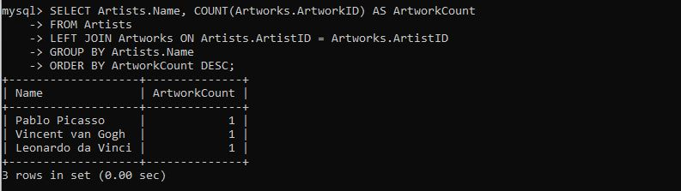

1. List the titles of artworks created by artists from 'Spanish' and 'Dutch' nationalities, and order them by the year in ascending order.

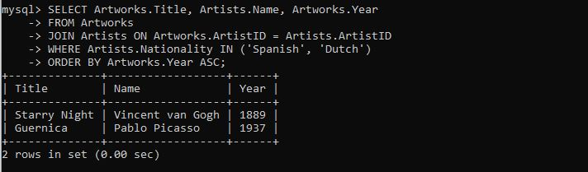

1. Find the names of all artists who have artworks in the 'Painting' category, and the number of artworks they have in this category.

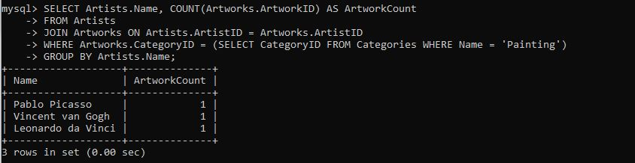

1. List the names of artworks from the 'Modern Art Masterpieces' exhibition, along with their artists and categories.

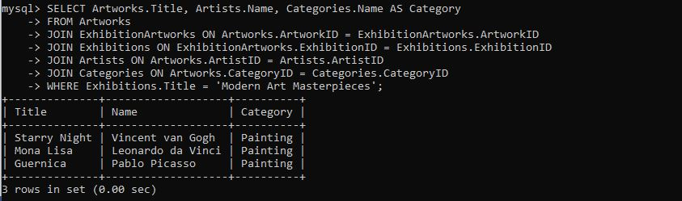

1. Find the artists who have more than two artworks in the gallery.

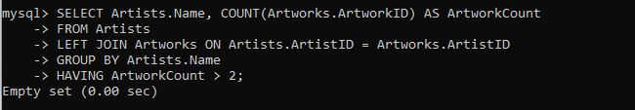

1. Find the titles of artworks that were exhibited in both 'Modern Art Masterpieces' and 'Renaissance Art' exhibitions

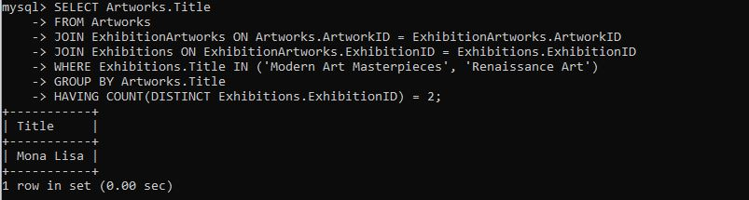

1. Find the total number of artworks in each category

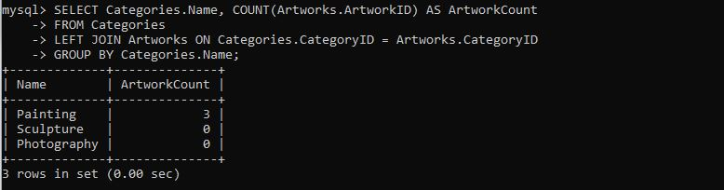

1. List artists who have more than 3 artworks in the gallery.

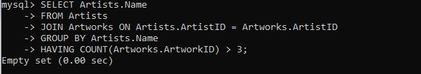

1. Find the artworks created by artists from a specific nationality (e.g., Spanish).

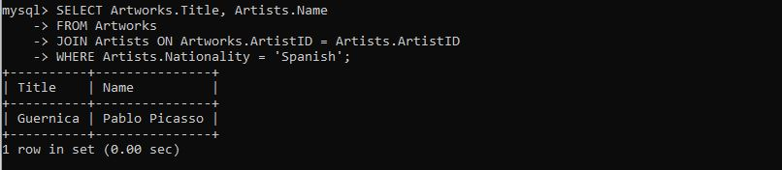

1. List exhibitions that feature artwork by both Vincent van Gogh and Leonardo da Vinci.

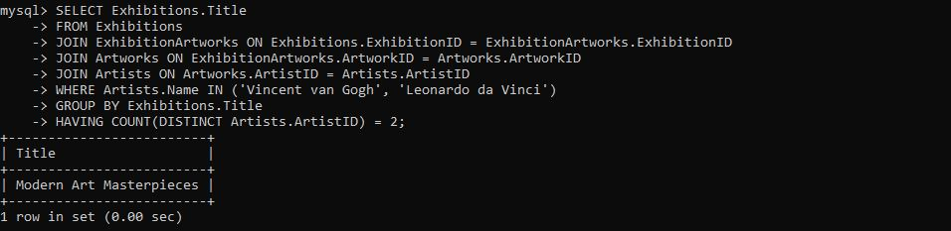

1. Find all the artworks that have not been included in any exhibition.

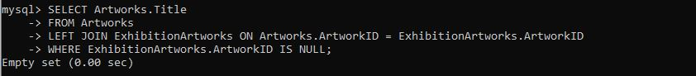

1. List artists who have created artworks in all available categories.

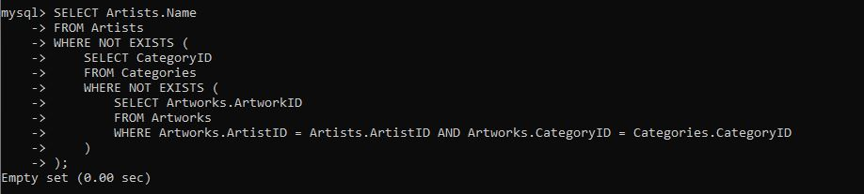

1. List the total number of artworks in each category.

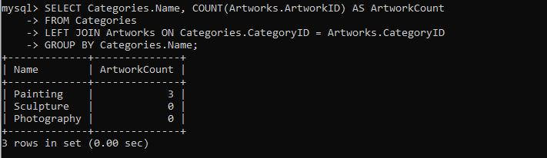

1. Find the artists who have more than 2 artworks in the gallery.

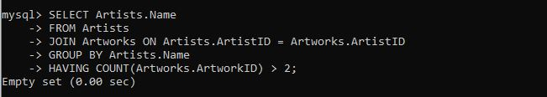

1. List the categories with the average year of artworks they contain, only for categories with more than 1 artwork.

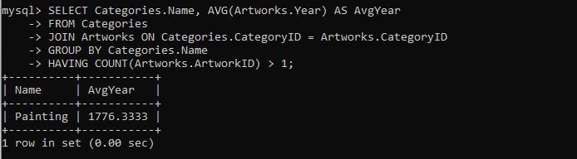

1. Find the artworks that were exhibited in the 'Modern Art Masterpieces' exhibition.

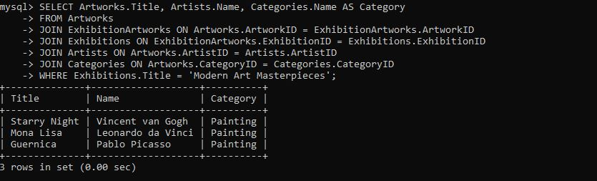

1. Find the categories where the average year of artworks is greater than the average year of all artworks.

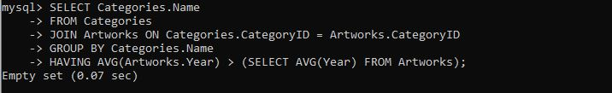

1. List the artworks that were not exhibited in any exhibition.

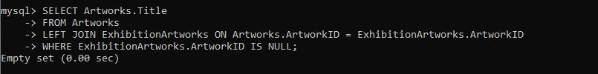

1. Show artists who have artworks in the same category as "Mona Lisa."

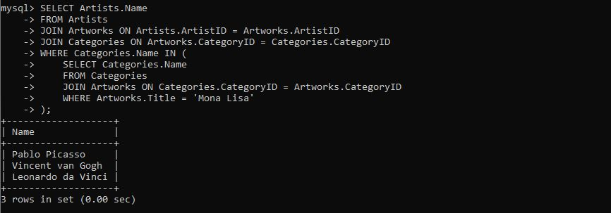

1. List the names of artists and the number of artworks they have in the gallery

